

Project name: | The Greenhouse | Project GS-no: | GS-412I
Contact name: | Joe Karten | Date: | 13/03/09

Administration
Signed Certification Agreement has been received by GBCA.
Certification Fee has been received by GBCA.
No Credit Interpretation Requests (CIRs) are outstanding.
No Invoices are outstanding.
Latest Green Star Excel rating tool has been downloaded from www.gbca.org.au
Submission Notification Form has been forwarded to GBCA at least 1 week prior.
Eligibility Criteria
Eligibility Criterion 1: Spatial Differentiation.
Eligibility Criterion 2: Space Use.
Eligibility Criterion 3: Conditional Requirements.
Eligibility Criterion 4: Certification Timing.
Submission Content
A General Section is included in the form of a consultant brief or short report which includes:
- an overview of the project;
- architectural drawings (e.g. elevations, site plan, etc);
- a floor-by-floor area summary table for nominated area (e.g. NLA, GFA etc); and
- a completed Green Star Excel spreadsheet, including ‘Building Input’, which accurately reflects the credits and points being claimed.
Credit Cover Sheets (based on GBCA template) are included for all claimed credits, including ‘na’ (not applicable). NB: Credit Cover Sheets are not required for credits not being claimed.
All relevant communication with the GBCA is included (e.g. CIR Rulings and Technical Clarifications relevant to the project) in the applicable credit.
All inputs are consistent throughout the submission. For example; the fresh air rates claimed in IEQ-1 ‘Ventilation Rates’ must be consistent with the Energy Modeling in Ene-1.
All reports, letters and drawings refer to the project, are on letterhead and signed where stipulated or where they confirm a commitment.
Relevant sections of the reports and specifications are highlighted to facilitate navigation.
Relevant elements of drawings are highlighted/clouded (esp. small items).
If the documented solution is complex or uncommon, diagrams and an explanation are provided to assist the assessment.
Design projects: Drawings are NOT in draft form (i.e. Preliminary, Green Star Submission Issue, For Information Only etc.). Construction Issue and Tender drawings are acceptable.
As Built projects: Drawings are As Built.
Specifications and reports are not in draft format.
All drawings are still legible after scanning, especially small stamps, monitors, sensors, sub-meters etc.
Credits claimed ‘na’ (not applicable) include the required supporting documentation.
Submission for each credit includes all documentation stipulated in the Technical Manual i.e. does not indicate “information to follow”. Appendices for each credit can be included, but they must be included within the credit folder and be clearly referenced and highlighted.
Submission Presentation
The CD must clearly identify the following:
- Project GS-number;
- Project name and address;
- Green Star rating tool and version;
- Date of submission; and
- Round 1 Submission.
Folders are included within the digital submission (CDs) and correspond to Green Star Categories (including a separate folder for the ‘General’ section) and are in the correct order e.g.
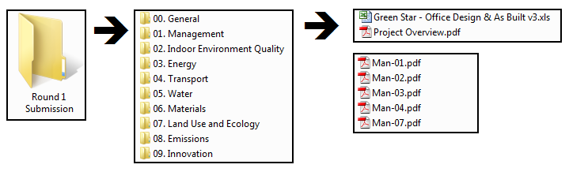
Within each category folder, one (1) merged PDF file is provided per credit and documents are tabbed to facilitate navigation.
All PDF documents are orientated in the same direction and no blank pages have been included.
Four (4) copies of the digital submission (CDs) have been provided.
Submission Delivery
Send four (4) digital copies of the submission to:
GBCA Case Manager
Green Star Certification Team
PO Box Q78 QVB NSW 1230
Green House, Level 15, 179 Elizabeth Street, Sydney, NSW 2000
GBCA Pre-Assessment Review: Round 1 Submission - SUCCESSFUL
GBCA Case Manager to notify project contact advising of successful Pre-Assessment Review and date Round 1 Assessment results due (6 weeks from receipt of submission).
GBCA Pre-Assessment Review: Round 1 Submission - UNSUCCESSFUL
GBCA Case Manager to notify project contact advising of unsuccessful Pre-Assessment Review including a list of the required amendments. The Round 1 Assessment will not be scheduled until the project submission meets all the requirements outlined in this checklist.

